App Development Project Report
1. Student Details
Name: Monalisa Das
Roll Number: 24F2008935
Email: 24f2008935@ds.study.iitm.ac.in
About Me: I am a Student at IIT Madras BS Degree program with a keen interest in learning web development. I’m also pursuing my B.Tech in CSE (with specialization in Cyber Physical Systems) and I like learning new things that are innovative.

2. Project Details
Project Title: Campus Recruitment Management System Statement:
Many institutes still rely on spreadsheets, emails, and manual tracking to manage campus placements. This leads to a range of problems:
- Duplicate student or company registrations
- No centralized visibility into active placement drives
- Difficulty tracking individual student application status
- Slow, error-prone company approval workflows
- No consolidated placement history for reporting
The Placement Portal solves all of these by providing a centralized, role-based web application that manages the entire campus recruitment lifecycle.
Approach:
The application was built using Flask as the backend framework with Jinja2 templates for frontend rendering. SQLite manages data persistence. The system supports three distinct roles:
- Admin (Placement Cell)
- Approves or rejects company registrations and placement drives
- Blacklists or deletes student/company accounts
- Searches students by name, ID, email, or phone
- Searches companies by name
- Views complete placement history and all application data
- Monitors stats: total students, companies, drives, applications
- Company
- Registers and waits for admin approval before logging in
- Creates, edits, closes, and deletes placement drives
- Views student applications per drive with full profile details
- Updates application status: Shortlisted, Selected, or Rejected
- Manages company profile including HR contact and description
- Student
- Self-registers with name, email, phone, CGPA, branch, and graduation year
- Browses all approved, open placement drives
- Applies for drives with duplicate prevention enforced
- Tracks application status in real time from the dashboard
- Views full application history with drive and company details
- Edits profile and uploads a resume (PDF/DOC/DOCX)

3. AI/LLM Declaration
I used Claude (claude-sonnet) and ChatGPT (GPT-5) to assist with:
- Generating the initial project structure and Flask blueprint architecture
- Writing the base versions of SQLAlchemy model classes with relationships
- Drafting the HTML/Jinja2 templates for admin, student, and company dashboards
- Suggesting route logic for role-based access control and session handling
The extent of AI/LLM usage is approximately 40–45%. All final implementation logic, debugging, template customization, validation, integration testing, and documentation were performed manually. The student verified all code, tested each user flow, and resolved all issues independently.

4. Technologies and Frameworks Used
Technology / Library | Purpose
Flask | Core backend web framework and route handling via Blueprints
SQLAlchemy (Flask-SQLAlchemy) | ORM to define models and auto-create SQLite schema
Jinja2 | Template engine for dynamic HTML rendering across all pages
Bootstrap 5 | Responsive UI layout, cards, tables, forms, and badges
HTML5 & CSS3 | Page structure and custom styling with CSS variables
Werkzeug | Secure password hashing (generate_password_hash / check_password_hash) and file handling
SQLite | Lightweight embedded database; auto-created on first run via db.create_all()
Bootstrap Icons | Icon set used throughout the UI for visual clarity

5. Database Schema / ER Diagram
Tables:
- Admin – Stores the pre-seeded superuser account (no registration flow).
- Student – Stores student profile and academic information.
- Company – Stores company profile details with admin approval and blacklist flags.
- Drive – Represents a placement drive (job posting) created by an approved company.
- Application – Tracks each student’s application to a placement drive with status updates.

Relationships:
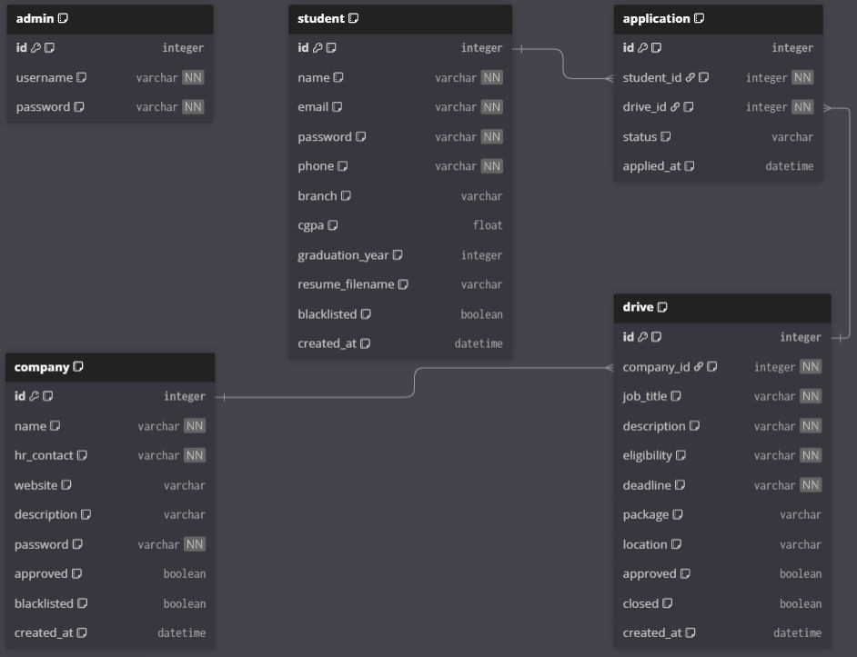
( drawn using dbdiagram.io )
6. API Resource Endpoints
Endpoint | Method | Description
/api/students | GET | Fetch all registered students (admin only)
/api/students/<id> | GET | Retrieve profile of a specific student
/api/companies | GET | Fetch all registered companies (admin only)
/api/companies/<id> | GET | Retrieve profile of a specific company
/api/drives | GET | List all approved placement drives
/api/drives/<id> | GET | Get details of a specific placement drive
/api/drives | POST | Create a new placement drive (company only, must be approved)
/api/drives/<id> | PATCH | Edit or close a placement drive (company only)
/api/applications | GET | Get applications — students see their own; companies see their drive applicants
/api/applications/<id> | PATCH | Update application status: Shortlisted / Selected / Rejected (company only)
/api/search/student | GET | Search students by name, email, phone, or ID (admin only)
/api/search/company | GET | Search companies by name (admin only)
/api/student/history | GET | Fetch full application history for the logged-in student
/api/admin/approve/company/<id> | POST | Admin approves a pending company registration
/api/admin/approve/drive/<id> | POST | Admin approves a pending placement drive

YAML API Definition File:
Included separately in the submission ZIP as hms_api.yaml.
https://drive.google.com/file/d/1b2EF1Ayh8hUzxDXyvn6sQ_CzskSplwWY/view?usp=sharing

7. Architecture and Features
Architecture Overview:
- app.py
- Flask application entry point; initialises all blueprints and database
- Auto-creates tables via db.create_all() on first run
- Seeds the admin account (username: admin, password: admin123) if absent
- config.py
- Centralises SECRET_KEY, SQLite database URI, and upload folder path
- models.py
- Defines Admin, Student, Company, Drive, and Application SQLAlchemy models
- Includes back-references and foreign key relationships between models
- auth.py
- Handles login (three roles via role tab selector) and registration routes
- Enforces blacklist and approval checks on login for students and companies
- Uses Werkzeug for secure password hashing and verification
- admin.py
- Blueprint for all admin operations at /admin/ prefix
- Approve/reject companies and drives; blacklist/delete students and companies
- Full-text search for students (name, email, phone, ID) and companies (name)
- Complete application history view across all users
- student.py
- Blueprint for all student operations at /student/ prefix
- Dashboard shows both available drives and currently applied drives with live status
- Apply route checks for duplicates before creating a new Application record
- Profile edit supports name, phone, CGPA, branch, graduation year, password, and resume upload
- company.py
- Blueprint for all company operations at /company/ prefix
- Enforces that only approved companies can create drives (checked at route level)
- Dashboard shows drive list with per-drive applicant counts
- Full CRUD for drives: create, edit, close, delete
- Application status update (Shortlisted, Selected, Rejected) with ownership check
- templates/
- base.html — shared navbar with role-aware navigation links and Bootstrap 5
- admin/ — dashboard, students, companies, drives, applications pages
- student/ — dashboard, drive details, history, profile pages
- company/ — dashboard, create/edit drive, applications, profile pages
- static/css/style.css
- Custom CSS built on Bootstrap 5 with CSS variables for consistent theming
- Dark navy primary, blue accent, coloured stat cards, drive cards, table styles
- Google Fonts: Plus Jakarta Sans (body) and Space Mono (monospaced elements)
- database/placement.db
- SQLite database auto-generated on first run — no manual setup required
- static/uploads/resumes/
- Directory for student resume uploads; created programmatically if missing

Implemented Features:
- Role-based login for Admin, Company, and Student with separate session keys
- Role selector tabs on login page — no separate admin/company login URLs needed
- Student self-registration with duplicate email and phone prevention
- Company registration with admin approval workflow before login is permitted
- Admin dashboard with live counts: students, companies, drives, and applications
- Admin can approve or reject company registrations from the dashboard or companies page
- Admin can approve or reject placement drives from the dashboard or drives page
- Admin full-text search for students (by name, email, phone, or ID)
- Admin company search by name
- Admin can blacklist students and companies (toggle), and permanently delete students
- Complete application history view accessible to admin showing all records
- Company dashboard displays company info, all drives, and applicant count per drive
- Companies can create drives with title, description, eligibility, deadline, package, and location
- Companies can edit open drives, close drives to stop new applications, and delete drives
- Companies can view full student profiles (with CGPA, branch, resume status) per drive
- Companies can update application status: Shortlisted, Selected, or Rejected
- Student dashboard shows both available drives and their own applied drives with status
- Students can view detailed drive information before applying
- One-click apply with server-side duplicate check preventing multiple applications
- Full application history page with drive name, company, package, date, and colour-coded status
- Student profile edit: name, phone, branch, CGPA, graduation year, password, resume upload
- Resume upload accepts PDF, DOC, and DOCX formats up to 5 MB
- Only approved and non-closed drives are visible to students
- Blacklisted students are blocked at login with a clear error message

8. Video Presentation
Drive Link: https://drive.google.com/file/d/1ZXQh2f-yYb-m2UNv9AyXol3NpOazsa4y/view?usp=sharing

